The SRC Arena Track
A (sometimes) Mathematical Tour
Terry R McConnell
2015
Introduction
The indoor track facility in SRC Arena at Onondaga Community College was opened to the public in January 2012. Situated in a 200 by 300 foot LEED certified building, it features a 6 lane 200m indoor track with eight 60 meter sprint lanes, and adjacent long jump and pole vault pits. Publicity materials tout the fact that the track surface is made of 36% pre-consumer recycled material, but do not specifically identify the surface. It appears to be Mondo Super-X.
Since its opening, the facility has been the default site for Section 3 indoor track meets, which had formerly been held in Syracuse University’s Manley Field House until the track there was demolished by SU to make room for an indoor field turf practice facility. The non-standard 3 lane track that remains in Manley is not suitable for competitions.
SRC arena also hosts other kinds of indoor athletic competitions, for example basketball games on temporary courts that can be set up in the infield of the track. Seating for basketball games is provided by retractable bleachers that cannot be used for track meets since they cover up much of the track. Indeed spectator seating is a problem when indoor track meets are held. For the most part, spectators must stand and look over the railings on the floor above track level. The facility also commonly hosts trade shows, banquets, and other public events, at which time the track is not available for use.
Access to the track during times when it is not in use for athletic or other events is controlled by the YMCA, which also administers the fitness center located in the same building. YMCA members and students and staff of OCC have access to the track, but not members of the general CNY community.
In what follows we attempt to provide detailed information on markings, distances, and other aspects of the track that would be of interest to runners. In the next section we tour the track, focusing on the various markings and their meanings. The second section is considerably more technical and deals with the details of mathematical calculations of distances. Since detailed blueprints have not been made available to the public, we had to resort to indirect means to infer several key parameters of the track. Undoubtedly there are some mistakes and inaccuracies, and we apologize for that. Any corrections or additions would be greatly appreciated by the author.

Part I: A Tour of the Track
The start/finish area of any track is busy with marks of various sorts, but SRC track presents an especially bewildering array of lines, curves, and other assorted markings. This is mainly because the designers chose to have the start/finish areas of both sprint lanes and 200m oval lanes coincide. There are 8 sprint lanes, each 48 inches wide, and 6 oval lanes, each 36 inches wide. (The 36 inch width is standard for an indoor track, but 48 inches is wider than normal – it conforms to the international IAAF standard rather than the standard for high school and college tracks, a standard that only requires 42 inch sprint lanes.)
The 8 sprint lanes extend well inside the 200m oval, and the effect of two independent sets of lines and curves merging uneasily in the homestretch is akin to op-art. More than one inexperienced runner has run out of lane entering the 2nd straightaway, unable to parse the jumble of curved and straight lines.
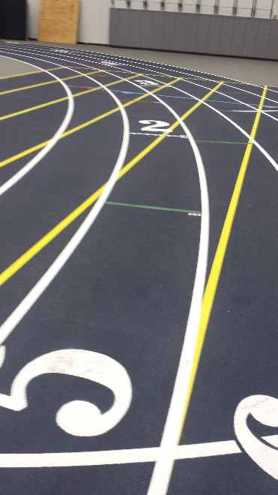
In the picture below we can see just a small part of the curved starting line in the foreground. The grid of sprint lane lines (yellow) and oval lane lines (white) is clearly visible. The short horizontal lines in the lane ahead are the one turn (green) and 2 turn (blue) stagger lines (more on those later.) A long blue line can also be seen across the track in the distance. It is the end of the exchange zone for the 4x400m relay race. (The beginning of the exchange zone is an equal distance behind the viewer. It is also marked by a blue line straight across the track. )
Let’s take a brief tour of the other markings in the vicinity of the start/finish area. (Some of these we will discuss in greater detail below.) First and foremost is the finish line, the place where all runners want to arrive as quickly as possible. It is white and is scribed straight across the track at the point where the first curve begins, i.e., it is perpendicular to the straight section of track that ends at the same point. Like all lines and curves on the track, the finish line is 5cm wide. The theoretical finish line is a mathematical line (no thickness) that coincides with the front edge of the painted finish line, the edge the runners will reach first. (Coaches often yell “run through the finish” at their runners, but that has more to do with making sure they maintain their finishing momentum than making sure they actually cross the true finish.) You will note that the places where the lane boundaries (both curved and straight) cross the finish line are marked in black, contrasting with the white and yellow color of the lane boundaries themselves. This is to help in alignment of automatic timing equipment.
Coincident with the finish line at the inner edge of the track, but curving in front of it as one moves outward, is the waterfall start. The use of the word “waterfall” in this context is somewhat obscure. Perhaps it is reminiscent of the curved shape of Niagara Falls? When athletes line up for the start of a race, those further from the inside of the track must run extra distance across the track in order to reach the inside edge, which is where everybody wants to be, since the distance around the curved parts of the track is least at the inside edge. If runners were lined up along the finish line, those furthest from the edge would be at a disadvantage. The curvature of the starting line compensates for the extra distance across the track by giving those further out what amounts to a “head start”.
As mentioned above, the straight blue lines parallel to and bracketing the finish line mark the boundaries of the exchange zone for the 4x400m relay race. Runners are required by the rules of the relay to pass the baton inside the boundaries of the exchange zone. The width of the entire exchange zone is 20m, so the first blue line is 10m in front of the finish, and the second one is 10m beyond. These lines are marked with triangles pointing towards the inside of the zone, which serve as reminders of the lines’ purpose.
The 4x200m relay also has an exchange zone marked with red lines that sport red triangles pointing toward the inside of the zone. In lane one, the beginning of this zone coincides exactly with the one for the 4x400m. Accordingly, the triangular arrow on that line is split into a blue half and a red half, to remind officials of the dual purpose of this line. (This seems less confusing than coloring the line maroon.) What about the other lanes? This is a bit confusing. For all exchanges except the first, the same blue lines as for the 4x400m mark the ends of the 4x200m exchange zone. The runner receiving the baton in the first exchange, however, must stay in her lane for the entire lap, and this requires a separate marker for the boundaries of the zone in each lane. These are marked by short red lines that otherwise look like stagger lines except that each sports its own red triangle. As a team, then, the 4x200m runners race in lanes around 3 turns, and accordingly they start at the red 3 turn stagger line in their assigned lane. These are, however, different red lines than the end of zone markers – they lack the red triangle.
The 4x800m relay uses the same exchange zone as the 4x400m. (We should perhaps be thankful that the designers of SRC track did not provide marks for running the 4x100m!)
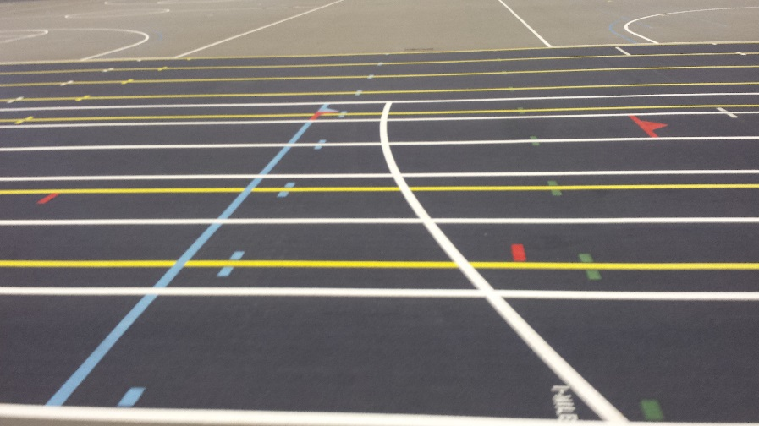
In this picture you can see the straight blue line marking the start of the exchange zone with its multicolored triangle. In lane 2 the short red line marking the beginning of the first exchange for the 4x200m is visible. The very short red lines in lanes 4 and 5 are also associated with the 4x200m. They mark the beginning of the acceleration or fly zone. In short relay races like the 4x100m or 4x200m the runner receiving the baton is allowed to start running outside the exchange zone in order to match speeds with the incoming runner who will pass him the baton. Here the receiving relay runner may start accelerating at the short red line (or closer to the exchange zone if he prefers). It is 10m from the beginning of the fly zone to the beginning of the exchange zone.
What’s that white curved line? It is the starting waterfall for the one mile race. One mile is exactly 1609.344m long. If runners start from the usual starting line and run 8 laps they will have run only 1600m, not one mile. Accordingly, the starting line for the mile is placed 9.344 meters behind the usual starting line. (It is curved for exactly the same reason as the usual starting line.) Want to know what .656 meters looks like? It’s the shortest distance you can see between the blue line and the white curve. That’s because, as you recall, the blue line is 10m from the finish line.
Let’s return to the start/finish area and talk about the rest of the marks visible there. We mentioned stagger lines very briefly earlier. There are 4 sets of stagger lines present in the start/finish area of SRC track. Stagger lines are used as starting lines in races where runners must stay in their lanes for some or all of the race. For very short races such as can be run entirely in a straight line (using, for example, the 8 sprint lanes of SRC track) the runners all line up for the race side by side. But when the race goes around a curve, runners who are in lanes further out from the inside of the track run a longer distance. For example, in the 200m race the runners complete a full circuit of the track, which involves going around two semi-circular curves. To be fair, these runners need to be given a “head start”, just as were those who started on the common starting line away from the inside of the track. In that case the extra distance was quite small because the runners merely had to cross to the inside of the track along a slanting diagonal, but around a full curve the extra distance is much greater in outside lanes than in lane one. Accordingly the head start runners must be given in races run in lanes is much greater, and greater still for lanes further out, and for races that require runners to stay in lanes around more than one curve.
Starting in, say, the outside lane, and proceeding counter-clockwise around the track, you encounter 4 color-coded stagger lines: green, white, blue, and red. These same 4 lines are found in all lanes except the first, but in lanes 2 and 3 the blue and white lines are so close to each other that they overlap and are shown as dotted lines with alternating blue and white “dots”.
The green lines are called the one-turn stagger lines and they compensate runners for having to run in lanes around just the first turn of the track. This would be the case in the 100m race, for example, but this is rarely run indoors. More commonly, the one turn staggers are used in longer dash races (200, 400, 600), where the runners are allowed to move to the inside lane as soon as they have rounded the first curve. The blue lines are two turn stagger lines, and the red lines are 3 turn stagger lines. The latter are used in the 4x800m race as we discussed above, and more rarely in the 800m individual race when it is run in lanes. (You will normally only see this in elite-level races where the 800 is so fast as to be almost a dash race. In high school and most college meets the 800 is started on the waterfall.)
What about those white stagger lines? They are used in the 200m race when it is run around 2 turns, whereas the nearby blue lines are used when the 400m race is run around 2 turns. The difference between the two races is a bit subtle. A 200m runner runs around 2 turns and then finishes, whereas a 400m runner still has a lap to go, run (mostly) in lane 1. The key point has to do with the “mostly.” The 400 meter runner, if she follows the shortest route, begins her second lap after a long diagonal traverse of the homestretch to get from her assigned outside lane to the inside lane for the beginning of lap two. The shortest path actually reaches the inside some distance around the curve (further or less depending on which lane the runner broke from), and so the runner was forced to run slightly further around curves away from the inside than a runner who ran the whole race in lane 1. The small gap between the blue 200m 2 turn stagger and the white 400m 2 turn stagger accounts for this difference. (The blue lines are just a bit ahead of the white ones, giving the 400m starter a slightly larger head start.) Even officials sometimes get this wrong. At the high school state meet one year, 400m runners were started from the wrong stagger lines.
There is only one more marking we need to consider in the start/finish area. It is a white waterfall curve similar to the common start and located a short distance ahead of it, but this curve begins in lane 3 and extends to the outside of the track. It is used in a special kind of start in distance races called a “California Box Start.” It combines features of a stagger line and a waterfall curve. The distance races (3000m, 3200m) often have large fields because they take up so much time that only one or two sections of each can be run. When there are too many runners to line up safely (and fairly) along the usual starting line, the starter may opt to move a bunch of runners up to a secondary start located at the California Box curve. As soon as the gun is fired, these runners may head to the inside of lane 3, but they must remain in lane 3 throughout the rest of the first curve. You will note that the box curve coincides with the one-turn stagger line (green) in lane 3 at its inside end. Thus, effectively, it staggers the whole bunch of runners in the same way as a lone runner starting at the 1 turn stagger line.
Let’s leave the start/finish and walk approximately ¼ of the way around the track to the beginning of the backstretch, where we find a curved green line that extends from the outer edge of lane 1 to the outside of the track. This curve is one of two such curves called “break lines”, whose purpose is to tell runners when they are permitted to leave their lanes and head for the inside of the track. This action, permissible of not, is called “breaking for the pole”. “The pole” is synonymous with the inside edge of the track, and is another of those old track terms of uncertain origin. Probably this one comes from horse racing, where significant distances were often marked with posts placed near the inside edge of the track. The break line is curved for reasons similar to the starting line: it is further to the pole from lanes further out, but the necessity of this curvature is not so obvious here since distances could always be evened out by adjusting the staggers. On the other hand, without an actual break line placement, one could not mark the subtle difference between 200m and 400m staggers, since the two depend on each other. A second reason why break lines are marked as waterfalls rather than straight lines or some other shape is disarmingly simple: the rules of Track and Field require it. There is another green break line located near the beginning of the home straightaway, and mainly used in the 400m, as discussed earlier.
Inexperienced runners often make the break incorrectly. You will see them make a near right turn after crossing the break line in order to get to the inside of the track as quickly as possible. They should use the entire length of the straightaway in order to reach the inside - running a long straight diagonal, rather than a bent curve over to the inside and then along it. The former path is significantly shorter than the latter. (These runners have probably been yelled at for “not moving to the inside”, and have been permanently scarred by it.)
Continuing further around the track we find a secondary starting area located exactly half-way around from the common starting area discussed in detail above. This is used in races whose distances are not even multiples of 200m – the 300, 500, and 1500 being the most commonly run examples. This area has its own retinue of secondary markings, including California box start, one turn stagger lines (green), two turn stagger lines (blue), and 3 turn stagger lines (white, not red.) The green or blue lines could be used for the 300m, depending on whether runners can break after one or two turns. I would guess the white lines are very seldom used. They might be used, for example, in a very serious and fast 500m race. There is also one straight 48 inch lane whose outside edge coincides with the outside edge of the oval and which extends to about the middle of the track. This is the approach to the pole vault pit.
Continuing around to near the start of the homestretch we come to the starting area for the sprint races, which are run in the wide straight lanes marked in yellow. There are 8 such lanes and they are each 48 inches wide. The additional width has less to due with the burly build of sprinters and more to do with the fact that hurdles often need to fit inside of them, and most schools have only one set of hurdles – those designed for the wider (42 inch) lane width of outdoor tracks.
The sprint races, including hurdles, all finish at the same line as the distance races, but two different straight starting lines are provided. The one that is nearly aligned with the end of the bleachers is the 55m dash start, and the one further back from the finish is the 60m dash start. The yellow line marking the beginning of the sprint lanes appears to be located 2.5 meters beyond the 60m start and is probably not used for any purpose in track. (There is a similar yellow line at the far end of the sprint lanes which aligns with the start of the long jump pit.) If one used the blue exchange zone lines as finish lines then it would be possible to run sprint races of 45m, 50m, 65m, and 70m in addition to the “official” two. (Come to think of it, you could even run a 20m “dash” from one end of the exchange zone to the other. How’s that for a fast twitch event?)
Finally we come to the home straightaway with its many multicolored hurdle placement markings. If you look down the track from the 55m or 60m start lines you will note a series of what seem to be dotted lines crossing the track at intervals that appear to be rather random. Each dotted line consists of separate dash marks in pairs bracketing the yellow lane lines. These mark hurdle placements, and can be used as guidelines for setting up hurdles for 4 different events: The 60m hurdles for men and women, and the 55m hurdles for men and women. Different colors are used to distinguish the markers for each of the 4 events. All four events require 5 ranks of hurdles, and therefore there are 5 dotted lines in each of the 4 colors. The color coding is: yellow for women’s 60m; blue for men’s 60m; green for women’s 55m; and white for men’s 55m. The distance to the first hurdle in the men’s events is 13.72m, and the distance between hurdles is 9.14m. In the women’s events the distance to the first hurdle is 13m and the distance between hurdles is 8.5m. In the following table we give the full set of hurdle markings, showing in each case the color of the mark, the event it is used for, the distance from the 60m start, the distance from the 55m start, and the distance from the finish line:
Hurdle Ranks 1-10
Rank | 1 | 2 | 3 | 4 | 5 | 6 | 7 | 8 | 9 | 10
Color | Y | B | G | W | Y | B | G | W | Y | B
Event | W60 | M60 | W55 | M55 | W60 | M60 | W55 | M55 | W60 | M60
From 60 | 13 | 13.72 | 18 | 18.72 | 21.5 | 22.86 | 26.5 | 27.86 | 30 | 32
From 55 | 8 | 8.72 | 13 | 13.72 | 16.5 | 17.86 | 21.5 | 22.86 | 25 | 27
From Finish | 47 | 46.28 | 42 | 41.28 | 38.5 | 37.14 | 33.5 | 32.14 | 30 | 28

Hurdle Ranks 11-20

Rank | 11 | 12 | 13 | 14 | 15 | 16 | 17 | 18 | 19 | 20
Color | G | W | Y | B | G | W | Y | B | G | W
Event | W55 | M55 | W60 | M60 | W55 | M55 | W60 | M60 | W55 | M55
From 60 | 35 | 37 | 38.5 | 41.14 | 43.5 | 46.14 | 47 | 50.28 | 52 | 55.28
From 55 | 30 | 32 | 33.5 | 36.14 | 38.5 | 41.14 | 42 | 45.28 | 47 | 50.28
From Finish | 25 | 23 | 21.5 | 18.86 | 16.5 | 13.86 | 13 | 9.72 | 8 | 4.72

The distances equal to a whole number of meters are of some interest in that the corresponding marks can be used as start or finish lines in conjunction with the start/finish and exchange zone lines to produce a great variety of different sprint distances. For example, a 40m dash could be run by starting at the 3rd hurdle placement of the women’s 60m hurdles and finishing at the far end of the 4x400m exchange zone.
Part II: Distances, Curvatures, and Other Mathematical Details

The length S of the straightaways is a key parameter in the design and description of a track because it uniquely determines the radius of curvature (R) of the circular parts, and this in turn determines distances that can be run in various lanes. The reason is that the circular parts must be semicircles. If they weren’t, there would be corners formed where the circular parts join the straight parts. From this, and the formula for the circumference of a circle, it follows that we have the relation
,
where D is the length of one lap along the measured line in lane one. (200m in the case of SRC track.) Lacking a detailed blueprint, we had to measure S somewhat indirectly. We measured with a steel tape the distance from the 55m start line along the outside lane line in sprint lane 8 to the beginning of the straight section of the track. This point occurs 2 feet past the first white hurdle placement marker, which measured 45 feet from the start line. Converting to meters and subtracting from 55m, this gives S = 40.6744m, which looks suspiciously like 40 and 2/3 meters. The corresponding value of R is 18.884m.
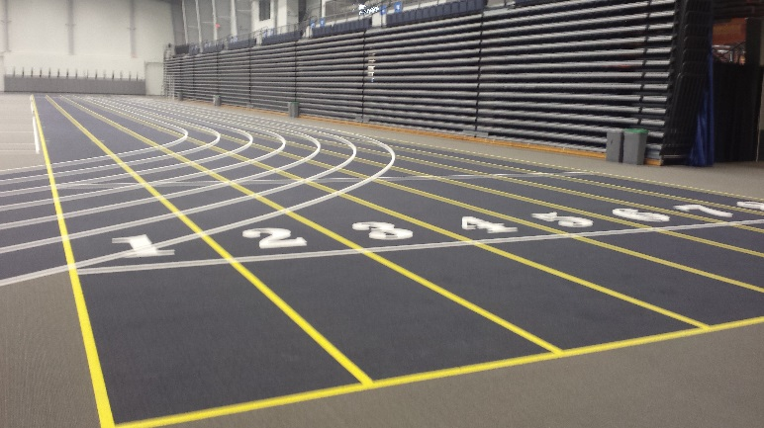
We can check the consistency of this figure with other things we know about the track by using a bit of geometry. Consider the picture shown of the area around the 55m start line (further white line visible.) Notice that the outermost circle is tangent to the outside of sprint lane 8 at the beginning of the straight section of the track. Call this point A. Also note that this same circle intersects the 55m start exactly at the outside lane line of sprint lane 4. Call this point B, and denote by C the center of the circular arcs. Line segment AB is a chord in a circle of radius CA, and so its length can be found from the angle it subtends at the center. But there is another way to find this same angle: The length d we measured as 47 feet is the side opposite this angle in a right triangle whose hypotenuse is the radius CB. (It extends from point B along the outside line of lane 4 until a point just inside the innermost circle at the beginning of the straightaway.) Thus, we have
The length CB is not R, but approximately 6 lane widths more. The reason I say approximately is because R is not the radius of the inner circle, but rather the radius of the measured line on the track, which is 8 inches, or 20 cm inside lane 1. Thus, CB = 18.884 + (6x3 ft.)x(0.3048) – 0.2 = 24.17m. Using for d the measured value of 47 ft. = 14.3256m, we find that the angle θ = 0.6344 radians.
The length of a chord that subtends 0.6344 radians in a circle of radius 24.17m is 15.0776m. This is the computed length of line segment AB. But, again referring to the picture, AB is also the hypotenuse of a right triangle, one of whose legs is our measured 47 feet, and the other being the part of the 55m start line in lanes 5 through 8. According to the Pythagorean Theorem, the square of 15.0776 = 227.334 ought to be the sum of squares of 14.2356 and (4x4ft)x(0.3048) = 4.8768. The sum of squares is in fact 226.43. The square root of this is 15.05, in excellent agreement with 15.08. (The difference is of the order of the width of a lane line, which is normally 5 cm)
In summary, we conclude that the straightaways of SRC track measure 40 and 2/3 meters, and the curves measure 59 and 1/3 meters. (Many outdoor tracks have equal length curves and straightaways, but the geometries of indoor tracks are more variable.)
As noted above, we assumed the measured line on SRC track is 20cm from the inside edge of the track, i.e. from the inside edge of the white stripe marking the left side of lane 1 as seen by runners. We have not been able to verify from anyone who actually participated in measuring the track that 20cm is the correct figure. Many tracks are measured 30cm from the inside. It appears that all modern rulebooks agree that if a track is built with a permanent curb then the measured line should be 30cm from the inside, and if there is no curb then the line must be 20cm from the inside. Very few modern outdoor tracks are built with a permanent curb, and essentially no indoor tracks are built this way, so it is difficult to know what to make of the 30cm rule.
Most modern rulebooks also seem to require that if there are no permanent curbs, then some substitute for them must be in place during races. Some track meets assemble temporary metal railings around the inside of the track, in roughly the position a traditional curb would have been placed. More commonly, you will see traffic cones or some kind of rubber berm put along the inside lane edge during meets to substitute for missing curbs.
If a given track installation intends always to have temporary curbs in place during races (as the rules seem to require), then should the track have been measured off a 30cm line or a 20cm line? Using 30cm conforms to the spirit, if not the letter, of the rulebook, while using 20cm is a “safer” option in that you can never be accused of having allowed runners to run short, but times on your track may be slightly slow. In the end, no amount of reading rule books can ever resolve the question of how the track actually was measured. (At SRC track there actually IS a way to settle the question using markings on the track. See below when we discuss the waterfall start lines.)
With regard to straightaways, one interesting question is “what are the longest and shortest straightaways allowed under the rules?” Unfortunately, this, and many other similar questions are ambiguous since they beg the question “which rules?” There are a great of number of different governing bodies that make rules about track and field competitions – IOC, IAAF, NCAA, NAIA, state and local athletic governing bodies – and each one has its own set of rules. To make matters worse, the rulebooks are amended almost every year, so to be precise, one must specify not only the governing body but the calendar year in which a specific rulebook was published.
For example, I have on my bookshelf an old TAC rulebook published in 1988. (TAC was the predecessor of USATF.) Like most rulebooks, this one is very precise about lane widths, measurement lines and such, and the word “track” is used dozens of times; but strangely, nowhere in it could I find any definition of what is a track. Perhaps a track could be an arbitrary shape, perhaps even crossing itself, to the hazard of competitors’ lives and limbs!
Let us define a track, for the purpose of these notes, to be a straightaway capped with semi-circles. The measured line is some distance from the boundary, defined by the rules. Clearly the straightaways cannot exceed 100m, or else the whole track would be more than 200m around. A very extreme track would be very long – close to 100m – with tiny circular U-turns at the ends. There would be almost no “infield”, an advantage to runners in that it would sharply curtail other scheduled activities that need an infield.
The limiting case would be a simple 100m stripe on the floor, with runners whipping by each other on opposite sides of the stripe, after having made an abrupt about-face at either end.
At the opposite extreme, a track with no straightaway at all would be a perfect circle, and so would the measured course be a circle of radius R = 31.83m = 200m/(2π). Since it costs runners more effort to accelerate around sharper bends, this track would arguably be the “fastest” design, but there are tradeoffs that argue for having some amount of straightaway. Circular tracks take up the most space, and so are presumably more costly to site. (This fact, in slightly more general terms, is a very important and celebrated mathematical theorem in its own right, called the Isoperimetric inequality. Remember your calculus? If farmer TrackCoach has 200m of fence, what shape does he make his fence in order to fence in the largest area? A square, but if you’d let him, he’d do better with a circle. That is what the inequality says. )
Another consideration would be safety for runners, especially in distance races. The repetitive stress of going around a constant radius curve with no let-up would probably lead to higher injury rates. For whatever reason, most indoor tracks are built with significant straightaways. The old 200m Manley Field House track had 15m straightaways, and was generally considered to be quite circular, among tracks. Few indoor tracks have the more elongated shape of the standard outdoor track. I believe the old Barton Hall track was similar in shape to an outdoor track, and runners thought it to be slower than Manley because of the sharper turns.
With 40m straights I’d put SRC slightly on the circular side, though, as an admittedly old and slow runner, I’ve not found it to be especially fast. It feels every bit of 200 meters around to me.
Let’s turn to the consideration of the waterfall curves, since they are quite the most sophisticated mathematical topic on the track. Recall that the waterfall is designed to provide each runner lined up along it an equal shortest distance to the finish. In theory, if runners of equal speed all start at the same instant, they will all plow into each other at the instant the outermost runner reaches the pole. But, at least it’s fair.
The precise shape that does this is not the arc of a circle. Starting from a circle, all runners would head towards the same point (the center), whereas on a track, every starting runner who wants to minimize the distance to the finish line will run a tangent to the inside lane, and this tangent reaches the inside lane at a different point along it for each runner. The further out from the inside a runner starts, the further along the track their shortest path to the finish meets the inside of the track.
The true curve is called an involute of the circle. It can be described in common terms as the path your fingers follow as they unwind yarn from a ball of yarn, all the while keeping the unrolled strand taut and confined to a single plane. If you use a suitable parameter, this curve has a simple and rather elegant equation:

We assume the origin is at the center of the semicircular first curve of the track, and the x-axis coincides with the finish line. Here r is the usual polar coordinate of the point along the waterfall curve, but θ is the polar coordinate of the point on the inside of the track where the line from the point along the waterfall curve is tangent. If θ could increase to infinity, the curve would approach the Spiral of Archimedes

asymptotically, but we only see a very small part of this curve for theta near zero. (For a derivation of the equation of the involute, see my article on the waterfall start at the old Manley 200m track.) The article also describes the method surveyors use to scribe an approximation to this curve on a track. The equation for the California box waterfall is the same, except we need to increase R by the width of 3 lanes.
The shape of the starting waterfall provides a hint to the location of the measured line on the track. It can be shown from the detailed equations of the waterfall curve that it meets the measured line at a right angle. At SRC track, the waterfall is continued all the way to the inside edge of the track, but this final section of it is perfectly straight. Accordingly, the length of the straight section of the waterfall plus the 5cm width of the line marking the inside edge of the track should give the offset of the measured line. (I say “should”, because there is no way to be absolutely sure the line was marked the way it was measured, or measured the way it was marked. Only the people who did the work know for sure.)
As for the break line at the head of the homestretch, it is also a waterfall that equalizes the distance run tangent to the far curve at the beginning of the 2nd lap, for runners breaking there from the various lanes. One can derive an equation for this curve, but it is not very useful, and the surveyors’ method for scribing it is exactly the same as for the starting waterfall. The curvature ends up being much less because the lengths of tape involved are so much larger.
In the following table we list our computed values for the distance to the waterfall from the finish line along the measured line in each lane. We give distances in both meters and feet, and give similar figures for the box start waterfall and for the break lines. (In the case of the break lines and mile start, the finish line is replaced by a line parallel to it that intersects the break line at the outside of lane 1.)
 | Lane 2 | Lane 3 | Lane 4 | Lane 5 | Lane 6
Start (m) | 0.195 | 0.569 | 1.077 | 1.718 | 2.496
Start (f) | 0.640 | 1.867 | 3.533 | 5.636 | 8.189
Mile (m) | 0.042 | 0.162 | 0.351 | 0.606 | 0.925
Mile (f) | 0.138 | 0.531 | 1.152 | 1.988 | 3.034
Box (m) |  |  |  | 0.180 | 0.524
Box (f) |  |  |  | 0.591 | 1.179
Break (m) | 0.010 | 0.042 | 0.093 | 0.165 | 0.258
Break (f) | 0.033 | 0.138 | 0.305 | 0.541 | 0.846

In a sense, the shape and location of the break line is rather arbitrary: it could be scribed straight across, or placed anywhere along the homestretch, as long as the gap between the white and blue 200m and 400m stagger lines is adjusted accordingly. After discussing placement of stagger lines, we shall return to this point and see if we can account for the actual gap that exists at SRC.
To understand placement of stagger lines, it is necessary first to understand how distance around the track varies with lane. More precisely, if you run around the track keeping a constant perpendicular distance x from the measured line, how much farther do you run than the 200m on the measured line? Since distance along the straightaway is the same no matter what the value of x (so long as it’s constant), the answer is the same if we remove the straightaways altogether and run around a circle of Radius R+x. The excess distance then is clearly just 2πx.
This brings up an old thought experiment I love to tell my calculus classes. Imagine one has a steel band cinched tight around the entire circumference of the Earth at its equator. Now imagine we cut the band at some point, insert an additional six inches of length, and make the band whole again. It will now have loosened somewhat. How much? Would it be (a) loose enough to slip your hand under; (b) loose enough to work a playing card under; or (c) not even loose enough for that? Most people choose (c), figuring that a mere six inches added in all that vast 24,000 mile length of steel tape is completely negligible. The surprising answer is (a). In this case, we wonder how much the radius grows when we increase the circumference by 6 inches. The answer is 6 inches divided by 2π, or just under an inch.
In the 200m, which is once around the track, a runner in lane N will run an extra (2π)(36)(N-1) inches = 5.75534(N-1) meters, since each lane is 36 inches wide. The solution of the stagger line placement problem now seems simple, doesn’t it? Just move the start forward by exactly that same amount in each lane, and you will compensate the runner for the extra distance.
The appropriate stagger s for k turns run in lane N is given by
The following table gives the computed values for the staggers at SRC track. If you want to compare these with the real thing you should remember that s is an arc length, but you would measure the corresponding chord (straight line between ends) using a tape measure.

In the first 4 lines of the table the units of measurement are meters and the distances represent arc lengths, whereas the final 4 lines give straight-line distances in feet.
There remains to explain those mysterious gaps between white 200m two turn stagger lines and blue 400m two turn stagger lines. You can reproduce the gaps for yourself by going to the track and performing the following procedure: go to the 2nd green break line (near the head of the homestretch) and scribe a perpendicular line across the track (use duct tape, not paint!) starting from the inner end of the break line curve. The curve and the straight line should now look much like the starting waterfall and finish line, except that the curved line will be much closer to the straight one.
When 200m runners reach the perpendicular line, they all have run the same distance. The placement of the 2 turn stagger lines where they started (white) made sure this is true. These runners have only to complete the equal length straightaways ahead of them to finish the race. Were these runners suddenly transformed into 400m runners, they would be just about to cross their break line, where they would be allowed to cut across the long diagonal of the track to merge with the curve at the beginning of the final lap. The shape of the break line ensures they will run equal distances from there to the finish, if they do so optimally. Thus, only the gap between the perpendicular line and the curve in each lane needs to be added to the white 200m stagger line in order to reach the blue 400m stagger line.

January 14, 2015

